

**Wireframe Document**

**Customer Personality Analysis**



We Performed Exploratory Data Analysis on Jupyter Notebook and then created Tableau Desktop Dashboard.

Tableau Public Server Outputs

# Distribution of Age of the customers

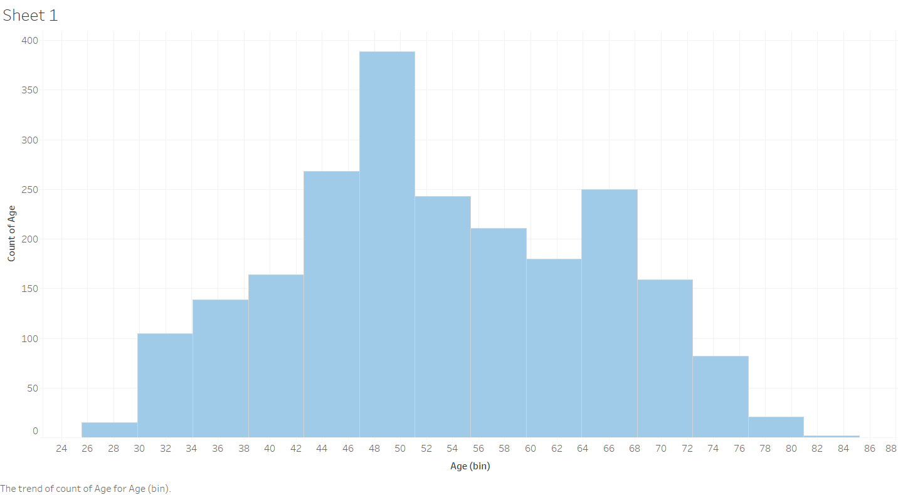

1)We can see that we have a normal distribution of age group.

2)With the mean somewhere around 50 year.

# Variation Of ‘TotalMnt’(Total Amount spent) with ‘age’ Variables

* 1. The Also the total amount spent by with respect to age if also a normal distribution with most of the sales are coming from age group between 44-68 year .

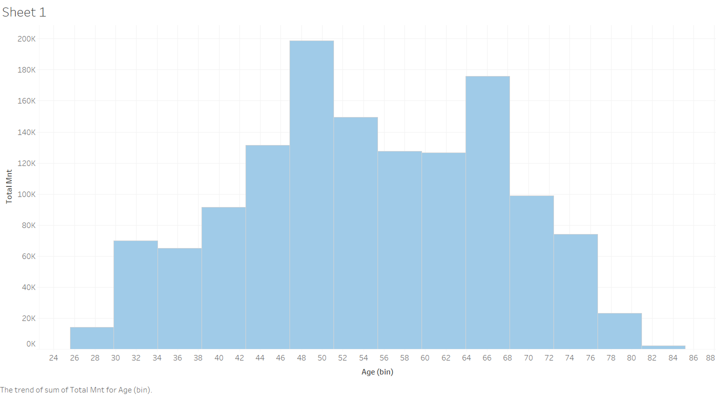

# ‘Education’ distribution

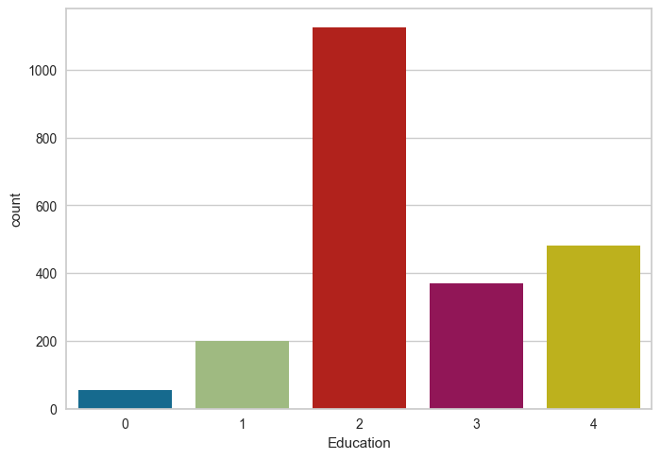

1. Here 0 is "Basic", 1 is "2n Cycle", 2 is "Graduation", 3 is "Master" and 4 is "PhD".
2. As we can see that most of the customers have done 2 ie Graduation level of educaiton.

# Variation Of ‘TotalMnt’(Total Amount spent) with ‘Education’ variables

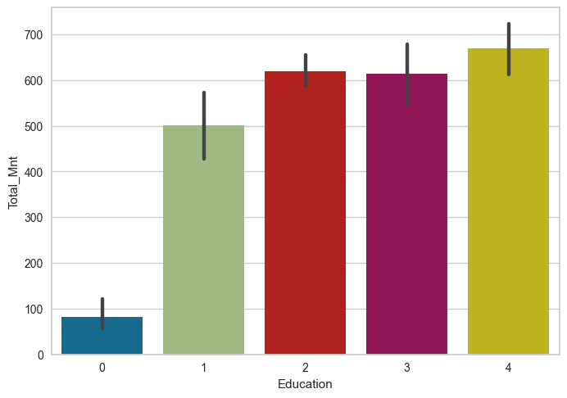

1. The customers having only Basic graduation are spending very less comparatively.
2. As we can see that as the education level increases , the total spendings is also going to increase.

# Variation of ‘TotalMnt’(Total Amount spent) with TotalMem(Total family member)

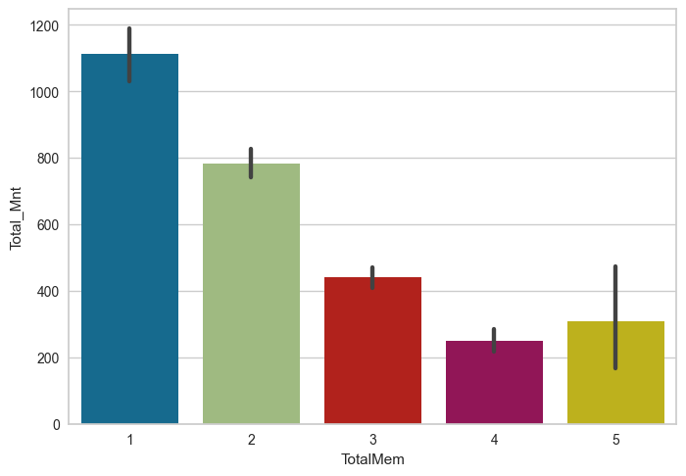

1. As we can see, most of our sales is generated by the customers which are having less family members ie 1 or 2.

# Variation of ‘TotalMnt’(Total Amount spent) with Total offer responses

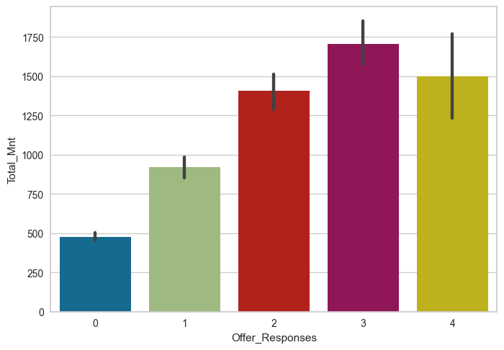

1. This is a graph showing the variation of the Total spendings with total offers accepted by the customer.
2. As we can see that, the customers which are accepting offers by the store are usually generating more sales to the store.

# Income Distribution with respect to total spendings

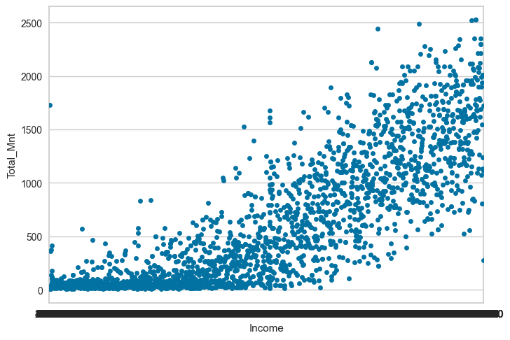

1. This graph shows the variation of the Total spending with Income distribution.
2. We can clearly see a linear relation between income and total spending in the stores.

# Box plot of clusters with ‘TotalMnt’(Total Amount spent)

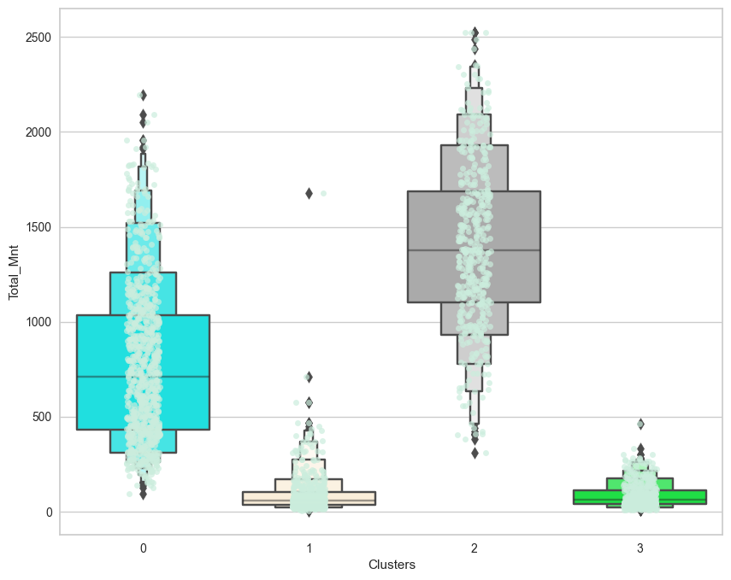

1. As we can see that most of higher sales (ie above 500) are generally made by only 2 clusters groups that are 0 and 2.
2. We can clearly get our best targetable customers for better sales further.